**Домашнее задание к занятию №28**

**Выполнил студент (ка)______________________________________**

**группа_______курс________ Специальность_______________**

**Задание №1 повторить основные формулы по теме:**



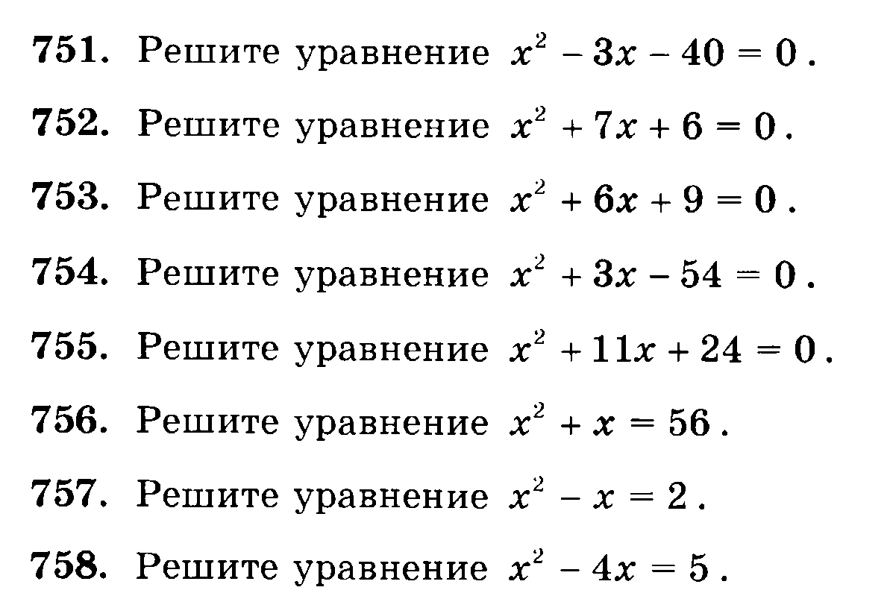**Задание №3 решить квадратные уравнения**

____________________________________________________________________________________________________________________________________________________________________________________________________________________________________________________________________________________________________________________________________________________________________________________________________________________________________________________________________________________________________________________________________________________________________________________________________________________________________________________________________________________________________________________________________________________________________________________________________________________________________________________________________________________________________________________________________________________________________________________________________________________________________________________________________________________________________________________________________________________________________________________________________________________________________________________________________________________________________________________________________________________________________________________________________________________________________________________________________________________________________________________________________________________________________________________________________________________________________________________________________________________________________________________________________________________________________________________________________________________________________________________________________________________________________________________________________________________________________________________________________________________________________________________________________________________________________________________________________________________________________________________________________________________________________________________________________________________________________________________________________________________________________________________________________________________________________________________________________________________________________________________________________________________________________________________________________________________________________________________________________________________________________________________________________________________________________________________________________________________________________________________________________________________________________________________________________________________________________________________________________________________________________________________________________________________________________________________________________________________________________________________________________________________________________________________________________________________________________________________________________________________________________________________________________________________________________________________________________________________________________________________________________________________________________________________________________________________________________________________________________________________________________________________________________________________________________________________________________________________________________________________________________________________________

**Задание №4 начертить графики функций: у=log (1/2)x; у=log (1/3)x; у=log (1/4)x;**

